Habitat International Coalition – Latin America Regional Office (HIC-AL)

2008 Activity Report

HIC members and friends in Latin America continue to work both to strengthen social processes and actors and to influence public policies in housing and habitat, at the local, national and regional levels. In the majority of cases, the training and formation activities and the campaigns and proposals (which include laws and other legal, administrative and financial instruments) are carried out in alliance with other organizations and networks, in turn contributing to give greater visibility to the Coalition.

The Latin American coordination office based in Mexico City (HIC-AL) supports the development, networking, exchange and dissemination of these processes in and among various countries of the region. For their part, the regional representatives (Félix Yanes of the Centro Memorial Martin Luther King-CMMLK of Cuba and Anelise Melendez of Fundación Pro Vivienda-FUNDAPROVI of Bolivia; and alternate delegates: Carmen González, Fundación Promotora de Vivienda-FUPROVI, Costa Rica and Leonardo Pessina, Centro de Asesoría y Autogestión Popular-CAAP, Brazil) as well as the Latin American representatives of the Women and Shelter Network to the HIC Board (María das Graças, Unión Nacional por la Moradía Popular-UNMP of Brazil and Diana Miloslavich, Centro de la Mujer Peruana Flora Tristán, Peru) continue to carry out a relevant role in promotion of HIC’s strategic themes: the rights to land, housing and the city; social production and management of habitat; the impact of mega-projects and forced evictions and displacements; disaster prevention and reconstruction processes.
The Right to Housing and the City in the new Constitution of Ecuador
On Sunday the 28th of September, through a national referendum, the people of Ecuador approved the new Political Constitution for said country. Within the “Rights to a good life,” the Constitution recognizes that “persons have the right to a safe and healthy habitat and to adequate and dignified housing, regardless of their social and economic situation.” At the same time, it highlights that “persons have the right to full enjoyment of the city and of its public spaces, under the principles of sustainability, social justice, respect for the different urban cultures and balance between the urban and the rural.” In that framework, it clarifies that “the exercise of the right to the city is based on democratic management, on the social and environmental function of property and of the city, and on the full exercise of citizenship” (chapter two, section six, articles 30 and 31).

Further down in the text are included details of the obligations and actions that should be undertaken by the state to guarantee said rights. Various HIC members actively participate within the Social Contract for Housing, which is an important effort of national networking that unites civil and social organizations, academia, independent professionals and other entities to influence public policies. From there, and inspired by the contents of he World Charter for the Right to the City, the proposals emerged that were finally included in the new Constitution of Ecuador.

During 2008, the HIC-AL office participated actively in the HIC global meetings (Assembly and Board meetings) held in February in Barcelona prior to the International Seminar on Women and the right to housing: constructing habitat from dignity organized together with Observatori DESC. Other participants in this international Seminar included representatives of the Latin American and Caribbean Committee for the Defense of Women’s Rights (CLADEM), the Center on Housing Rights and Against Evictions (COHRE) and the UN Special Rapporteur on the Right to Housing, Miloon Kothari. In early October, they were invited to participate in the coordination meeting of the regional project on Social production of habitat and the rights to housing and the city in Latin America: strategic focuses of regional HIC action to influence public policies (2005-2008) held in Guatemala during the III Social Forum of the Americas.

Said encounters have assisted the Coalition to further develop its analysis of current human settlements situations, both urban and rural, from a human rights perspective, and to advance from the local experiences in the diverse regions toward a common strategy. The agreements established point in particular toward greater strengthening of membership and of the social processes and actors, thanks to improved coordination of the bodies and structures that integrate
the Coalition: knowing more and better who we are, what we are doing, which thematic focuses can link our actions, what already-developed tools we can use, how to build greater social strength, with what movements and networks are we or should we be working, how to improve the training and communication instruments, and how to give greater visibility to our postulates.
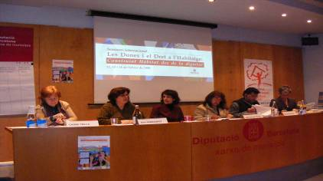
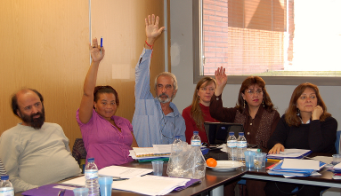

Some of the specific agreements on which we continue to work are:
- To register, share and disseminate training and formation materials developed by HIC members in various corners of the world over recent decades;
- To identify and make known legal, juridical, financial and other instruments linked to the right to housing, the right to the city and social production of housing, as well as the processes to influence public policies;
- To advance in the definition of the right to land in the international instruments and pressure for policies to facilitate access to land;
- To continue to exchange community organization experiences in prevention of forced evictions;
- To review and improve the effectiveness of the urgent actions system, including exploring possibilities to link efforts with other international networks.

Progress has been made at the Latin American level in the systematization of formation and training activities and products carried out by Coalition-member organizations in various countries. This process has now been opened to the entire membership (see synthesis document, invitation to participate, and more information). Based on this general diagnosis we hope to establish a database of resources that HIC can offer to its members and other interested networks and actors, increasing the synergies and visibility of our accumulated struggles and experiences. This process will be inscribed in the new global initiative of the HIC-Academy. As a first exercise in this sense, together with FEDEVIVIENDA (Colombia) a remotely-accessible electronic “virtual” course was organized on Urban and land management with the participation of 18 persons from 14 organizations in Argentina, Bolivia, Colombia, Costa Rica, Ecuador, El Salvador, Guatemala and Mexico. In addition, and thanks to the contributions of CMMLK (Cuba), we already have a proposed tool for the mapping of actors, which is being reviewed to integrate feedback from the regional representatives.

A greater and better linkage with other processes, movements and networks continues to be at the center of concerns and strategies at the regional level. Work continues to be developed in connection with members of the following organizations: Food International Action Network (FIAN); the Latin American Association of Promotion Organizations (ALOP); the Inter-American Human Rights Platform, Democracy and Development (PIDHDD), and the International Network on Economic, Social and Cultural Rights (DESC Network). In addition, institutional contacts have been established with both the Latin American Council on Adult Education (CEAAL) and the Continental Social Alliance (ASC) to investigate possible strategies for a more systematic institutional relationship that would allow us to interlink the themes in which each is working at the local/national and regional/international levels.

The right to the city, understood as urban reform proposal that guarantees the social function of land and property, a firm halt to speculation and evictions, and progress toward truly democratic
management of land, is confirmed as central focus that articulates actions in the majority of Latin American countries. It is clear that this is not a case of “starting from scratch” or of postulating the right as a mere abstraction, complex and difficult to implement. On the contrary, the proposal calls for advancing the identification of processes and instruments that already represent a substantial step forward in this direction, based in particular on that which has been learned and conquered in the promotion and implementation of the right to housing and social production of habitat. The HIC member organizations have been working along this path for many years, together with networks such as the Latin American Secretariat for Popular Housing (SELVIP), the National Forum for Urban Reform of Brazil (FNRU), the Center on the Right to Housing and Against Evictions (COHRE), Habitat for Humanity – Latin America and the Caribbean, and the International Alliance of Inhabitants (AIH), among others.
Organizations achieve approval of Law for public and free technical assistance for popular housing construction in Brazil
Considered a monumental victory of the social, civil, professional and academic organizations that have been promoting it since the 1970s (at first in southern Brazil and then spreading across the entire country), last December a new Law, Nº 11.888, was approved, that assures the right of low-income families (those earning up to 3 minimum wages), residents in urban or rural areas, to free public technical assistance for the construction of their own homes, as a guarantee of concrete implementation of the right to housing. Said support is for all the project, accompaniment and execution works, by professionals from the fields of architecture, urbanism and engineering, for the construction, adaptation, expansion or regularization of housing.
This new legislation also aims to avoid the occupation of high-risk and environmental-protection areas. It will be financed with federal public resources to be distributed to the municipalities. The technical assistance may be offered directly to the families or to cooperatives, inhabitant associations, or other representative organized groups. Selection of final beneficiaries and attention to their needs must be done through systems installed by the municipal collegiate bodies with joint composition among public representatives and civil society. For the training of the professionals and of the beneficiary communites regarding the provision of technical assistance services, work agreements may be signed between the responsible public entity and entities that promote professional training or university extension programs in relevant areas.
Said agreements should include technological innovation, formulation of participative methodologies, and democratization of knowledge. Measures will be implemented to assure that the social-interest housing programs benefited with resources from the National Fund for Social Interest Housing include free technical assistance.

For these purposes, within the framework of the III Social Forum of the Americas, we jointly promoted the Seminar on The Right to the City in Latin America: social mobilization and progress in the struggle for urban reform. The Seminar was attended by some 70 persons including more than 25 HIC member organizations from 10 countries, Women and Shelter Network members, and representatives of the noted networks, as well as youth, students and graduates of the University of San Carlos, which hosted the event. Details of the processes of struggle for urban reform in Brazil, Colombia, Ecuador and Mexico were shared, as well as the strategic bases of the right to the city and current regional articulation processes. The event also provided an opportunity to present the most recent HIC-AL publication on the theme. We also participated in separate activities coordinated by the Housing Network of the Swedish Cooperative Center on self-developed cooperativism and influencing public policies on land, housing and habitat.

An important prior process of regional articulation was developed -among HIC members and in close coordination with the noted networks- in the framework of preparations for the XVII Assembly of Maximum Housing and Urbanism Ministers and Authorities of Ibero-America (MINURVI) held in El Salvador in early September. As noted in the previous report (see HIC 2007 Annual Report, p. 20), said authorities now have a precise instruction of the Presidents to promote “the consecration of the right to the city” (point 29 of the Action Program of the XVII Ibero-American Summit of Heads of State and of Government, Santiago de Chile, 2007). In said context, various civil society organizations agreed to pursue the possibility to participate within the technical and ministerial meetings, presenting concrete proposals in writing, that contribute to advance in the implementation of the right to the city and urban reform in Latin America. After receiving a negative response to our request directed to the Technical Secretariat, the organizations opted to deliver a printed copy to all the authorities present of a Declaration of civil society organizations: proposals toward the implementation of the right to the city in Latin American urban policy, collectively elaborated and signed by more than 100 organizations from 14 countries through an intense process of communication and promotion over the course of the previous months (March-September 2008).

In parallel, and as part of our joint activities, more than 200 representatives of movements and networks from different countries of the region participated in the Forum on The Right of Latin American peoples to the city, coordinated by the Salvadoran Foundation for Development and Minimum Housing (FUNDASAL), Habitat for Humanity, the Housing Network of the Swedish Cooperative Center, and other local entities.

Also this year, regional representatives had relevant participations in HIC’s name in various national and international activities. They included the International Seminar on Cities without violence toward women, safe cities for all (Buenos Aires, Argentina, July) organized by the HIC Women and Shelter Network together with other women’s networks and the United Nations Development Fund for Women (UNIFEM). This Seminar provided a space for exchange and reflection on experiences that seek to advance women’s access to the city’s resources and benefits, guaranteeing security and non-violence in public and private spaces. The presence in Buenos Aires also facilitated a small meeting with some HIC members, in which they exchanged advances in the implementation of the regional strategy in the framework of the 2003-2008 regional project (with the participation of organizations from Argentina, Bolivia, Brazil, Colombia, Mexico, Peru and Uruguay). A similar initiative was undertaken with HIC members in Bogotá, taking advantage of participation in the Colloquium on Lectures on the city: contributions from research and the solution of its problems (Bogotá, Colombia, November) organized by the Housing Institute of Javeriana University. The research paper on “The housing dimension of human development” undertaken at the initiative of FUNDAPROVI (Bolivia) was also presented. For its part, the member of CMMLK (Cuba) shared his organization’s experiences in the field of popular education and political formation with integrants of the institutions affiliated to the National Network of Human Settlements -RENASEH (Cochabamba, Bolivia, August).
Achievements of the cooperative housing movements in Uruguay and Argentina: land and real estate holdings, mobilization and strengthening of national-level linkage
The Uruguayan Federation of Mutual-Aid Housing Cooperatives (FUCVAM), active member of SELVIP and HIC in Uruguay, has achieved important progress this year in two important areas: the creation of a Stock of Real Estate properties for Social Housing at the national level, held by the Ministry of Housing, and the constitution of Land Stocks in the provinces of Paysandú, Soriano, Canelones, Lavalleja and Maldonado, revitalizing those already existing in Montevideo and Flores. In addition, after months of arduous and difficult efforts, agreements were achieved with the national government regarding implementation of a subsidy policy for access to housing and security of tenure and the re-structuring of debts, as well as a new set of regulations regarding loans issued to cooperatives that eliminates previous loan discriminations based on income brackets.
For its part, the Movement of Occupants and Tenants (MOI), also an active member of SELVIP, HIC, and the Argentinean Workers’ Central (CTA), has made progress in the legal formalization and national-level construction of the Federation of Self-Managed Cooperatives of the MOI-CTA. Within that framework, and with the participation of more than 200 cooperative delegates from 6 Argentinean provinces, a document was elaborated and discussed on “Democratic cities and territories without expellers or expellees.” This document establishes solid bases for the development of popular policies on habitat, land and housing. It was also presented for debate in commissions in the Social Constituent assembly promoted by the CTA (held in San Salvador de Jujuy in October) with the participation of more than 8,000 delegates from 700 social, union, political and cultural organizations from throughout the country.
In the province of Buenos Aires, 4 experiences were developed of quality urban land acquisition within the framework of the Solidary Force Trust (soft credit that links habitat, the social economy, and solidarity) in the municipalities of La Plata, Avellaneda, San Martín and Merlo, involving 200 families as a starting point to promote a pilot operative and provincial normative framework of cooperative self-management.
Favorable local and provincial conditions, both in socio-organizational and governmental terms, were taken advantage of in the provinces of Neuquén and Tierra del Fuego and the municipalities of San Martín de los Andes, San Carlos De Bariloche, Ushuaia and Santa Fe, taking the first steps to advance framework agreements of cooperation and development of initial experiences in cooperative self-development of habitat, within a perspective of formulating general norms and programs.

Also in Bolivia, and by initiative of the regional representative, several events were developed to bring together HIC members: an International Seminar on the Human Right to Housing and Public Policies (Cochabamba, June), organized by RENASEH, with the participation of CAAP (Brazil); the International Seminar on Panorama of Housing Policies in Latin America and perspectives toward new alternatives (La Paz, August), organized by Red Habitat, FUNDAPROVI, and the Permanent Forum for Housing-FOPEVI, which enjoyed contributions from the HIC General Secretary (Chile), Casa y Ciudad (Mexico) and Universidad de General Sarmiento (Argentina). This type of articulation helps to make visible HIC’s technical capacities and the relevance of social production of knowledge from ongoing processes in the region –in the case of Bolivia, advancing legislative frameworks and public policies of social production of housing and habitat and the right to housing and the city; the International Seminar on Cities: prevention and adaptation measures in response to climate change (La Paz, December), organized by Red Habitat and with the participation of AVE-CEVE (Córdoba-Argentina) and 2 members of the former XIV-G Network on Habitat at risk of the Ibero-American Program on Science and Technology for Development –
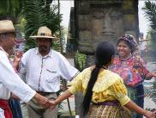
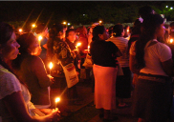
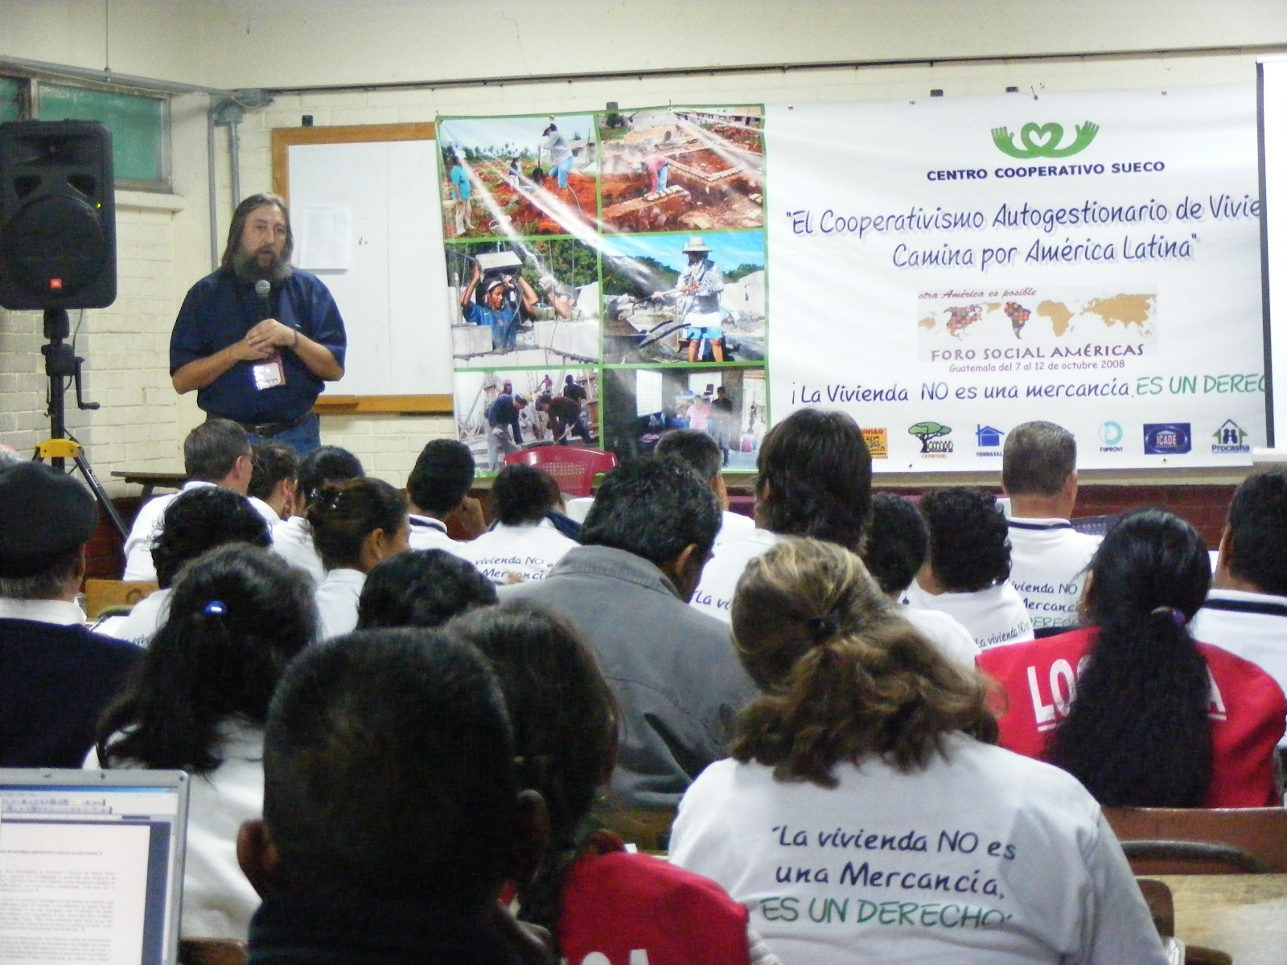
CYTED (Cuba and Brazil). It is important to note that this last initiative is inscribed within the objective to stimulate the HIC Habitat and Sustainable

Environment Network (HSEN) in Latin America, following up on agreements from the regional meeting held in October in Guatemala.

At the same time, representatives of the HIC-AL regional office made presentations at the IV Latin American Congress of Cities and Local Governments (Mexico City, August) organized by the Latin American Federation of Cities, Municipalities and Associations – FLACMA; the IV International Forum on Democracy and Cooperation (Cáceres, Spain, September), organized by the Institute of Policy Studies for Latin America and Africa (IEPALA), with the participation of networks from Africa, Asia, Europe and Latin America; the 52nd General Assembly of the International DESC Network (Nairobi, December), the International Forum on Housing and City Policies in Latin America and the III National Encounter of Social Organizations of Historic Centers (Lima, December), coordinated by the Center for Population Research, Documentation and Advisory (CIDAP) and neighborhood networks for urban renewal without evictions in various cities of the country. The latter event also offered the opportunity for a very productive working meeting with local HIC members.

In Mexico, together with HIC members and other organizations that form part of the Urban Popular Movement (MUP), as well as integrants of study, research and formation centers, pressure continues to be applied on the National Housing Commission to open spaces and supports (including public resources) for projects of social production and management of habitat in distinct locations in the country, thanks to which several organizations are already acting as distributors of subsidies for housing improvement and new housing construction. At the local level, negotiations have initiated with the Institute of Housing for the implementation of a community project of social production and management of habitat, while actively participating in the new Federal District Sustainable Urban Development Council (responsible for preparing the local program on sustainable urban development for the coming years) and in the elaboration process of the new Federal District Human Rights Program (in particular regarding the rights to housing and to water). This is a unique experience at the world level promoted by the UN High Commissioner for Human Rights and coordinated by the local Human Rights Commission. For their part, several HIC-member institutions in Mexico and MUP organizations are actively involved in the Neighborhood Improvement Program promoted in the capital city over the past two years, with important results and relevant lessons drawn from the evaluation processes.

In addition, as planned, during August the second edition of the social organization internships was carried out with the participation of 33 representatives from 9 Mexican states. The project had intended to include the participation of housing cooperative representatives from El Salvador but last-minute visa complications impeded their travel to Mexico. The agenda of themes addressed included the impacts of processes of urbanization and privatization of public spaces and services in cities and their surroundings (housing, water, waste, transportation); the perspective of the right to housing, land and the city and its relation with social production and management of habitat; collective forms of organization and work, and management and negotiation strategies and techniques. The activities included conferences, workshops, dialogue with authorities and field visits to communities affected by these processes in the Valley of Mexico and surrounding areas. Participants pointed out the significant wealth of these exchange experiences and the importance of continuing this project (a third edition in 2009).
Mexico City: Toward a Charter for the Right to the City
Social organization members of the urban popular movement (MUP), with support from the HIC-AL office, have been able to open a dialogue process with the local government for the formulation of a Charter for the Right to the City. As part of the process, a series of public events of promotion and exchange have been organized in Mexico City and in other regions of the country and diverse debate and dissemination materials have been produced.
The ad hoc Promotion Committee is initially made up by Urban-Popular Organizations of he National Democratic Convention, the Federal District (Mexico City) government, HIC-Latin America, DESC, the Federal District Human Rights Commission, and the Federal District Social Procurator’s office.
The formulation of this Charter is oriented to confront the profound causes and manifestations of exclusion: economic, social, territorial, cultural, political and psychological. It is postulated as a social response, opposed to the city-as-merchandise, and as expression of the collective interest. It is a complex approach that demands articulating the human rights theme in its integral conception (civil, political, economic, social, cultural and environmental rights) with that of democracy in its diverse dimensions (representative, distributive and participative). More information and available documents (conceptualization, proposals, photos, videos).

In early 2008, also with urban popular organizations and the Coalition of Mexican Organizations for the Right to Water (COMDA), the AIH, and FIAN, intense work was dedicated to the preparation, implementation and follow-up of the Tent on the Right to the City and Habitat, one of 9 tents that formed part of the VIII polycentric World Social Forum (held in the Mexico City center plaza, January). For 3 days, more than 1,300 persons of all ages attended seminars, workshops, photographic exhibitions, and cultural and entertainment activities related to the right to housing and the city, the right to water, and other economic, social and cultural rights. There, representatives from the city and the countryside exchanged their experiences around their problems and came to agreement on diverse proposals to advance in articulation. Several of these proposals are currently being implemented.
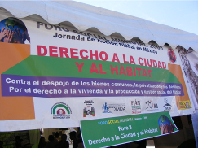
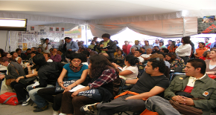
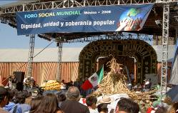
Among the important follow-up activities, support was provided for the organization and participation of social movements within the National MUP-CND Encounter, the IV Encounter of the Movement of Persons Affected by Dams and in Defense of Rivers (MAPDER) and the Popular Encounter on Water, Energy and Energy Alternatives held in Mexico. Also, a case was presented within the Latin American Water Tribunal in Guatemala and the Encounter of Urban Movements held in El Salvador (promoted by the SCC Housing Network), from which a regional strategy proposal emerged regarding access to land, elaborated by more than 25 organizations from 15 countries of the region.

As members of the Space on Economic, Social and Cultural Rights (DESC), HIC-AL worked throughout the year on issues such as: analysis of the content of the new technical cooperation agreement between the Mexican government and the Office of the UN High Commission on Human Rights (OHCHR) with headquarters in the country; participation in the elaboration of the Universal Periodic Review on the Human Rights situation in Mexico submitted to the UN Human Rights Council (July); the possibility to elaborate, in coordination with the OHCHR, reports on specific themes (water, housing, food, labor rights). In addition, each organization that forms part of DESC shared the progress made in the cases receiving direct attention (13 Pueblos of Morelos; contamination of the Santiago River and the Arcediano Dam project in Jalisco; La Parota Hydroelectric Dam project; cases of tuberculosis in Chiapas, etc.). Regarding the Mexican chapter of the PIDHDD, DESC members participated in activities on the criminalization of the social movements, migration in Latin America, and systematization of experiences in economic, social and cultural rights matters (HIC-AL very actively participated with the systematization of the La Parota Dam case).

For its part, the HIC General Secretariat is recognized in Chile as a resource for support for debate on the right to housing and the right to the city among the social actors involved in housing demands, and it is frequently called upon to offer presentations in schools of social leaders, social organizations, universities, etc. The HIC-GS participates in the Housing and City Observatory, which is a platform of articulation among 6 well-differentiated entities (Catholic Church, university, NGO). Following a year of the campaign for the right to housing in Chile, progress includes having brought together the most important national experts, having placed the “why” the right to housing
The struggles for the right to water in Mexico and in the world
HIC-AL continues its participation as international ally of the Coalition of Mexican Organizations for the Right to Water (COMDA), developing formation tasks and support to social groups and movements. COMDA maintains active dialogue with networks (such as the VIDA Network, for example, of which it is part) and international organizations (such as France Libertè-France, Council of Canadians-Canada, Food and Water Watch-USA, COAGRET-Spain). In support of the Mazahua indigenous-campesino movement of the state of Mexico (neighboring Mexico City) and as strategy to develop closer ties between rural and urban inhabitants, a reforestation day was held in June with the participation of Mexico City groups and movements.
Work continues in support of the Council of Peoples of Morelos, including with participation in the periodic meetings of the Council with their advisors. In conjunction with this work and in coordination with COMDA, meetings were organized in April to analyze the issues being faced from a specifically legal perspective.
In March 2009, parallel to the World Forum on Water (Istanbul, Turkey), COMDA will join the Week of Action in Defense of Water, which is a world platform of mobilization, protest, discussion and analysis to advance in the unity and consolidation of an international movement, preparing a series of documents (collective declaration, publication of case studies) and events of social, environmental, women’s and human rights defense organizations, in the framework of a Day in Defense of Water.

in the agenda of formation and debate among population leaders and debated the risk of confusing the “rights to housing and to the city” in academic discourse, and that the Ministry of Housing and Urbanism has recognized the campaign and one of its primary demands, the creation of an appellate entity not related either to the Ministry or to the Chamber of Construction.

HIC-GS representatives participated, together with the CMMLK, in an exchange visit on eco-materials (La Havana, Cuba, November) organized by the Building and Housing Social
Foundation/CIDEM; and various activities together with Red Habitat and FOPEVI (La Paz, Bolivia, August). In addition, throughout the year, classes and presentations are offered on the right to the city and the Chilean policy of housing finance within diverse academic events (International Diploma course on Specialization in public policies and DESC, Seminar on Housing and City policy in Latin America at the Universidad de General Sarmiento, Argentina; Diploma course on Territorial management and governance at the Pontificia Universidad Católica of Chile, classes on Social and urban impacts of the housing finance policy in Chile at the Universidad Alberto Hurtado, First National School for the Right to Housing (Santiago de Chile). One of the important challenges for the immediate future is to advance in the articulation of this sphere of work with the activities of HIC-AL in the region, and in particular to establish ties between Chilean inhabitants organizations and similar networks in other Latin American countries (such as those in support of persons with mortgage debts).

During much of the year, and in follow-up to agreements established by the HIC Assembly in Barcelona, the HIC-AL office collaborated closely with the General Secretariat in the elaboration of contents and review of the Spanish translation of the 2007 HIC Global Report.

In addition, as planned, in the month of August HIC-AL published the Spanish version of the book on The right to the city in the world: Compilation of relevant documents for the debate (disseminated at various regional events -MINURVI, FSA, etc.-), the English translation of which is underway; as well as a summary of the follow-up to the Mexican visit and recommendations of the UN Special Rapporteur for the Right to Adequate Housing, Miloon Kothari; a practical guide on human rights, development projects and evictions, together with the Mexican office of the UN High Commission on Human Rights; and a book on risks and vulnerability in the metropolitan area of Mexico City. In addition, integrants of the regional office have written several articles on themes addressed by HIC activities for the book on The current state of housing in Mexico, 2008 being prepared by CIDOC; the challenges for implementation of the contents of social production of housing of the new Housing Law in Mexico for the magazine Progressive Planning of the Planners Network, the regional articulation process around the right to the city in the COHRE electronic newsletter, and on the challenges for social housing in Latin America in the portal Asuntos del Sur. The office also collaborated in the translation to Spanish and the revision and publication of the text by Eike Schütz on the experience of Misereor in reconstruction processes in post-disaster situations in Central America.

In addition, since July, a project has been initiated to establish an inventory and to classify the HIC-AL Documentation Center to facilitate information consultations through internet, and to link with the virtual libraries of HIC members and other institutions, together with the implementation of a distribution plan of publications to universities, public entities, and members in the region (several dozen copies have already been delivered to more than 50 institutions in 13 countries).
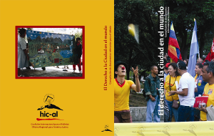

Thanks to the incorporation to the team of a social communicator, progress has been made in the production of various communication materials (especially videos and blogs), and relevant HIC news and documents have been distributed to other networks. In the second semester of 2008, a tool began to be tested involving an automated electronic monthly newsletter disseminated through the regional web page - will be regularly functioning during 2009.

At the same time, work continues to update the regional web page (with more than 100,000 visits and 500,000 views during 2008), through which a new section called HabitArte has been launched as a space for the concerns, dreams, actions and proposals of all inhabitants and in particular young people, so they may creatively express themselves through images, stories, and sounds from the street. As a first activity, in the framework of World Habitat Day and within the Campaign Acting Together for Housing!, a Latin American Film Festival on City and Social Movements was organized based on a selection of documentaries (from the Hispano-American Encounter All voices against Silence held in Mexico), making available to the interested organizations copies which can be shown in other cities.

HIC-AL Team
Mexico City
E-mail: info@hic-al.org
Website: www.hic-al.org

March 2009

The Universal Periodic Review (UPR) mechanism of the Human Rights Council is a new monitoring instrument implemented through the recent reforms in the heart of the UN human rights system. In the first months of 2009, the Human Rights situation in Mexico was publicly analyzed in the context of the UPR mechanism. Each country comes up for review every four years, and it is carried out by a Working Group conformed by the 47 countries that are members of the Human Rights Council. The exam is based on 3 reports: a national report presented by the country; a compilation prepared by the OHCHR of the information contained in the UN bodies and mechanisms regarding the country, and a summary prepared by the OHCHR of credible and trustworthy information from other actors, including civil society and national human rights commissions. DESC submitted information for the most recent report. Once the examination is concluded in the Working Group, the Group presents a report to the Human Rights Council so that the latter adopt the recommendations derived from the review, in a session open to the participation of states members, observers, and civil society.

